


Scope and Storyboard for LV MI User Front End

MI Team, Manchester

By Gareth Levingston

Table of Contents

1. Document Revision History 2
1.1. Document Location 2
1.2. Revision History 2
1.3. Reviewed by 2
1.4. Approvals (please complete ‘name’ column on first draft) 2
1.5. Distribution 2
2. Summary of Scope 3
3. Screen design 3
4. Workflow 3
5. Navigation 3
5.1. Where will the Flow be launched from 3
5.2. Where should the Flow return to 3
6. SQL Tables 3
6.1. Table 3
6.2. Lookup 3
6.3. Field 3
7. Stored Procedures 3
7.1. Fetch 3
7.2. Save 3
8. Document Templates 3
9. Javascript 3

Document Revision History

Document Location
Full File Path
\\Man05sql\Dev\Applications\Flosuite\Scopes\Zurich MI and MI structure enhancements\FL028 Scope and Storyboard Zurich MI User front end.doc

Revision History
Version Number | Revision Date | Summary of Changes | Changes marked | Author
1.0 | 18/04/2012 | First issue | n/a | GQL

Reviewed by
Name | Signature | Title | Date of Issue | Version
Lisa Williams |  | Project Manager
Andrea Brown |  | Test Analyst
Mark Jenkinson |  | Project Liaison Officer

Approvals (please complete ‘name’ column on first draft)
Name | Signature or  Date of Approval Email | Title | Date of Issue | Version

Distribution
Name | Title | Date of Issue | Version

Summary of Scope

This scope describes the current MI requirement for LV as a client in terms of Field Set with any required pick lists and subsequent data structure changes to accommodate the complete field set.

Screen design

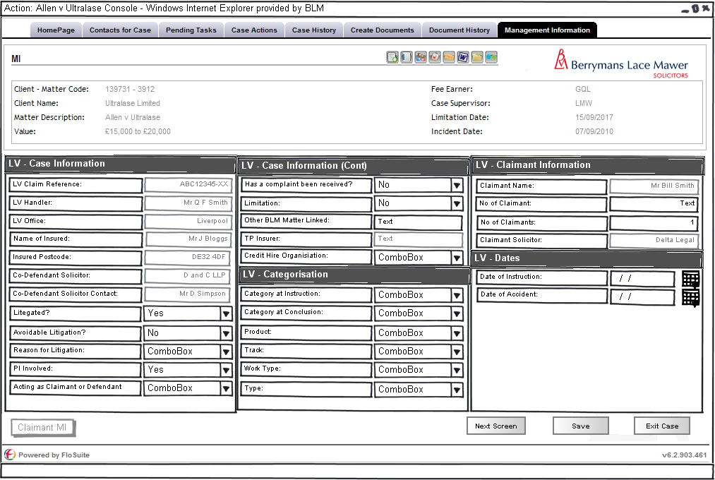

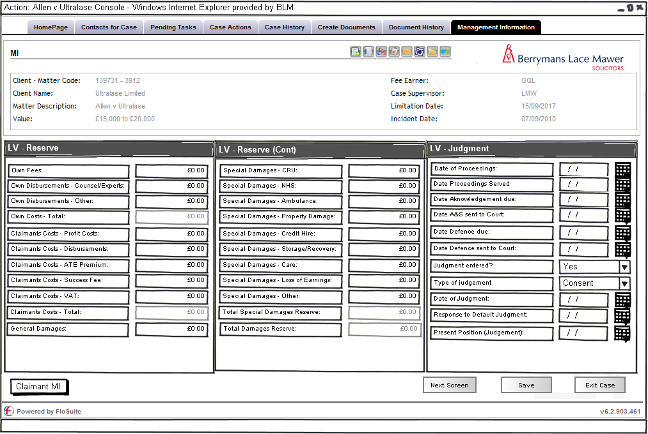

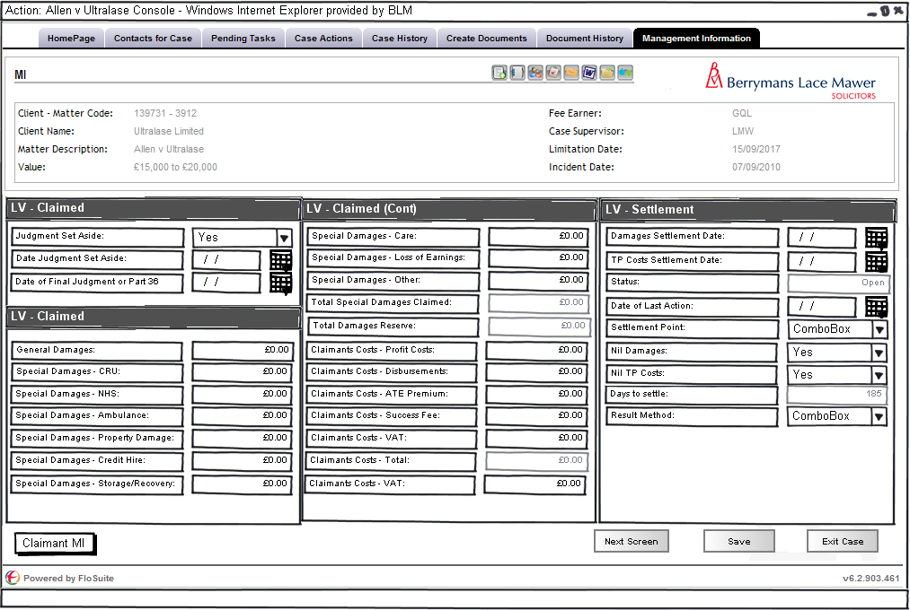

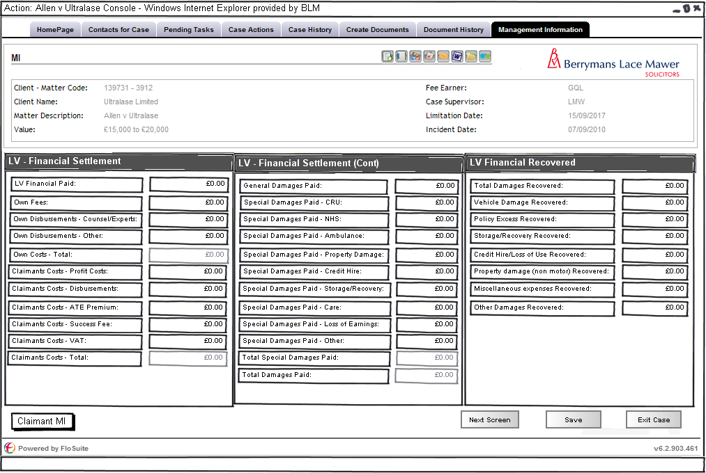

The above four diagrams show the screen layout designs for the LV MI based on the following data provided by the MI team:

Matter Centric MI

Field Name | Format | Expert Field? | Read Only? | Existing MI Field? | Code | notes
LV Claim Ref | text | No | No | Yes | MIFLD00002 | same as QBE field
LV Hander | text | No | No | Yes | CLTCLMHNDR | contact - same as QBE field
Name of Insured | text | No | Yes | Yes | case info | contact - same as QBE field
Insured Postcode | text | No | Yes | No |  | new field? - can this come from contact info?
Category at Instruction | picklist | Yes | No | No |  | read/write to aderant [ADERANTLIVEBLM].[dbo].[_HBM_MATTER_USR_DATA].[LV_CAT_AT_INST] (picklist TBA)
Category at Conclusion | picklist | No | No | Yes | MICFIELD94 | same picklist as Category of Work at Instruction
LV Office | text | Yes | Yes | Yes | case info | Read only from Aderant - similar to Z field - SQL to be provided
Date of Proceedings | date | No | No | No |  | from key dates?
Date Acknowledgement due | date | No | No | No |  | from key dates?
Date Proceedings Served | Date | No | No | No
Date of Instruction | date | Yes | No | Yes | Instruct | read/write from Aderant - same as Zurich
Date of Accident | date | Yes | No | Yes | AccDt | trigger to Aderant - same as Zurich
Date A&S sent to Court | date | No | No | No |  | from key dates?
Date Defence due | date | No | No | No |  | from key dates?
Date Defence sent to Court | date | No | No | No |  | from key dates?
Judgment entered? | Picklist | No | No | No |  | Yes/No options
Type of Judgement | Picklist | No | No | No |  | Consent/Default options
Date of Judgment | date | No | No | No |  | from key dates?
Response to Default Judgment | text | No | No | No |  | free text box
Present Position (Judgement) | text | No | No | No |  | free text box
Judgment Set Aside | picklist | No | No | No |  | Yes/No
Date Judgment Set Aside | Date | No | No | No
Date of Final Judgment or Part 36 | Date | No | No | No
Claimant Name | text | No | Yes | Yes | claimant info | from contacts? - is this held as separate surname / first name if not will have to captyure these separately
No of Claimant | text | Yes | No | No |  | read/write to aderant [ADERANTLIVEBLM].[dbo].[_HBM_MATTER_USR_DATA].[NUMBER_OF_CLAIMANT]
No of Claimants | integer | Yes | No | No |  | read/write to aderant [ADERANTLIVEBLM].[dbo].[_HBM_MATTER_USR_DATA].[LV_NO_OF_CLAIMANTS]
Claimant Solictor | text | No | Yes | Yes | claimant info | contact - same as QBE field
Codef Sol | text | No | Yes | Yes | case info | is this a contact already?
Codef Sol Contact | text | No | Yes | Yes | case info | is this a contact already?
Damages Settlement Date | date | No | No | Yes | DamSet | same as QBE field
TP Costs Settlement Date | date | No | No | Yes | MICFIELD04 | same as QBE field
Status | text | No | No | Yes | ClmStsTxt | formula from Date of last action - if no date then Open else Closed - no need to write back to database
Date of Last Action | date | Yes | Yes | Yes | Settlement | Read only from Aderant - SQL to be provided (date of paymemt of final bill)
Litigated | picklist | No | No | Yes | MICFIELD108 | Yes / No
Product | picklist | Yes | No | No |  | read/write to aderant [ADERANTLIVEBLM].[dbo].[_HBM_MATTER_USR_DATA].[LV_PRODUCT] (picklist on product tab)
Has a complaint been received | picklist | No | No | No |  | Yes / No
Acting as Claimant or Defendant Firm | picklist | Yes | No | No |  | read/write to aderant [ADERANTLIVEBLM].[dbo].[_HBM_MATTER_USR_DATA].[LV_CLAIM_OR_DEF]
Track | picklist | Yes | No | No |  | read/write to aderant [ADERANTLIVEBLM].[dbo].[_HBM_MATTER_USR_DATA].[LV_TRACK] (picklist TBA)
Work Type | picklist | Yes | No | No |  | read/write to aderant [ADERANTLIVEBLM].[dbo].[_HBM_MATTER_USR_DATA].[LV_WORK_TYPE] (picklist TBA)
Type | picklist | Yes | No | No |  | read/write to aderant [ADERANTLIVEBLM].[dbo].[_HBM_MATTER_USR_DATA].[LV_TYPE] (picklist on type tab)
PI Involved | picklist | Yes | No | No |  | read/write to aderant [ADERANTLIVEBLM].[dbo].[_HBM_MATTER_USR_DATA].[LV_PI_INVOLVED] (Y/N picklist)
Settlement Point | picklist | No | No | No |  | picklist on settlement point tab
Avoidable Litigation | picklist | Yes | No | No |  | read/write to aderant [ADERANTLIVEBLM].[dbo].[_HBM_MATTER_USR_DATA].[LV_AVOID_LIT] (pre issue / "Yes" / "No" picklist)
Reason for Litigation | picklist | Yes | No | No |  | read/write to aderant [ADERANTLIVEBLM].[dbo].[_HBM_MATTER_USR_DATA].[LV_REASON_FOR_LIT] (picklist TBA)
Limitation | picklist | No | No | No |  | Yes / No
Nil Damages | picklist | No | No | No |  | Yes / No
Nil TP Costs | picklist | No | No | No |  | Yes / No
Result Method | picklist | No | No | Yes | MIFLD00034 | picklist on result method tab
Own Fees | currency | Yes | Yes | Yes | BLMCstFB | read only from Aderant - SQL to be provided
Own Disbursements - Counsel / Experts | currency | Yes | Yes | Yes | BLMCFB | read only from Aderant - SQL to be provided
Own Disbursements - Other | currency | Yes | Yes | Yes | BLMDB | read only from Aderant - SQL to be provided
Own Costs - Total | currency | Yes | Yes | Yes | BLMTotB | read only from Aderant - SQL to be provided
Own Fees Reserve | currency | No | No | Yes | MPROFCOSTS | FinancialReserve BLMProfCosts
Own Disbursements Reserve - Counsel / Experts | currency | No | No | No |  | new field?
Own Disbursements Reserve - Other | currency | No | No | No |  | new field?
Own Costs Reserve - Total | currency | No | Yes | Yes | BLMCstRes | formula - sum of previous 3 fields, read only but written back to FinancialReserve BLMCostRes
Days to settle | integer | No | No | No |  | formula - date instruction to date settement damages - no need to write back to database
Other BLM Matter Linked | text | Yes | No | No |  | read/write to [ADERANTLIVEBLM].[dbo].[_HBM_MATTER_USR_DATA].dbo.[LINKED_BLM_CASE]
Claimants Costs - Profit Costs | currency | No | No | Yes | TPPrCstSet | where are these held in the costs flows?
Claimants Costs - Disbursements | currency | No | No | Yes | MICFIELD26 | where are these held in the costs flows?
Claimants Costs - ATE Premium | currency | No | No | Yes | MICFIELD27 | where are these held in the costs flows?
Claimants Costs - Success Fee | currency | No | No | Yes | MICFIELD28 | where are these held in the costs flows?
Claimants Costs - VAT | currency | No | No | No |  | where are these held in the costs flows?
Claimants Costs - Total | currency | No | No | Yes | MICFIELD30 | sum of the 5 claimants costs fields writing back to the same place as Zurich
Claimants Costs Reserve - Profit Costs | currency | No | No | No |  | where are these held in the costs flows?
Claimants Costs Reserve - Disbursements | currency | No | No | No |  | where are these held in the costs flows?
Claimants Costs Reserve - ATE Premium | currency | No | No | No |  | where are these held in the costs flows?
Claimants Costs Reserve - Success Fee | currency | No | No | No |  | where are these held in the costs flows?
Claimants Costs Reserve - VAT | currency | No | No | No |  | where are these held in the costs flows?
Claimants Costs Reserve - Total | currency | No | No | Yes | FICURRESCO | sum of the 5 claimants costs reserve fields writing back to the database, where is this held in the costs flows
Claimants Costs Claimed - Profit Costs | currency | No | No | No |  | where are these held in the costs flows?
Claimants Costs Claimed - Disbursements | currency | No | No | Yes | MICFIELD14 | where are these held in the costs flows?
Claimants Costs Claimed - ATE Premium | currency | No | No | Yes | MICFIELD15 | where are these held in the costs flows?
Claimants Costs Claimed - Success Fee | currency | No | No | Yes | MICFIELD16 | where are these held in the costs flows?
Claimants Costs Claimed - VAT | currency | No | No | No |  | where are these held in the costs flows?
Claimants Costs Claimed - Total | currency | No | No | Yes | MICFIELD13 | sum of the 5 claimants costs claimed fields writing back to the database, where is this held in the costs flows
Total Damages Paid | currency | No | Yes | Yes | MICFIELD65 | Same field as QBE - Total Damages Paid (Gross); can this be a read only on screen field but write back to database with the sum General Damages and Total Special Damages fields below?
General Damages Paid | currency | No | No | Yes | MICFIELD63 | Same field as Zurich
Total Special Damages Paid | currency | No | Yes | Yes | SpDmStVl | Same field as Zurich - can this be a read only on screen field but write back to database with the sum of the 9 special damages paid figures below?
Special Damages Paid - CRU | currency | No | No | Yes | LXCRUVALUE | Financial CRUValue
Special Damages Paid - NHS | currency | No | No | Yes | IALXNHSVAL | Financial NHSValue
Special Damages Paid - Ambulance | currency | No | No | Yes | PdAmb | Financial AmbulanceValue
Special Damages Paid - Property Damage | currency | No | No | Yes | PRPDAMPAID | Financial PropertyDamagesPaid
Special Damages Paid - Credit Hire | currency | No | No | Yes | AMOUNTPAID | CreditHire AmountPaid
Special Damages Paid - Storage / Recovery | currency | No | No | No |  | new field?
Special Damages Paid - Care | currency | No | No | No |  | new field?
Special Damages Paid - Loss of Earnings | currency | No | No | No |  | new field?
Special Damages Paid - Other | currency | No | No | No |  | new field?
Total Damages Reserve | currency | No | Yes | Yes | MICFIELD77 | Same field as QBE - Current Damages Reserve (Gross); can this be a read only on screen field but write back to database with the sum General Damages and Total Special Damages reserve fields below?
General Damages Reserve | currency | No | No | Yes | RALDAMAGES | ReserveCurrent GeneralDamages
Total Special Damages Reserve | currency | No | Yes | Yes | IALDAMAGES | Same field as Zurich - can this be a read only on screen field but write back to ReserveCurrent SpecialDamages with the sum of the 9 special damages reserve figures below?
Special Damages Reserve - CRU | currency | No | No | Yes | ResCRU | Reserve_Current CRU
Special Damages Reserve - NHS | currency | No | No | Yes | ResNHS | Reserve_Current NHS
Special Damages Reserve - Ambulance | currency | No | No | Yes | ResAmb | Reserve_Current Ambulance
Special Damages Reserve - Property Damage | currency | No | No | No |  | new field?
Special Damages Reserve - Credit Hire | currency | No | No | No |  | new field?
Special Damages Reserve - Storage / Recovery | currency | No | No | No |  | new field?
Special Damages Reserve - Care | currency | No | No | No |  | new field?
Special Damages Reserve - Loss of Earnings | currency | No | No | No |  | new field?
Special Damages Reserve - Other | currency | No | No | No |  | new field?
Total Damages Claimed | currency | No | Yes | Yes | AMAGESCLMD | can this be a read only on screen field but write back to Financial DamagesClmd with the sum General Damages and Total Special Damages claimed fields below?
General Damages Claimed | currency | No | No | No |  | new field?
Total Special Damages Claimed | currency | No | Yes | No |  | can this be a read only on screen field but write back to the database with the sum of the 9 special damages claimed figures below?
Special Damages Claimed - CRU | currency | No | No | No |  | new field?
Special Damages Claimed - NHS | currency | No | No | No |  | new field?
Special Damages Claimed - Ambulance | currency | No | No | No |  | new field?
Special Damages Claimed - Property Damage | currency | No | No | No |  | new field?
Special Damages Claimed - Credit Hire | currency | No | No | Yes | UNTCLAIMED | CreditHire AmountClaimed
Special Damages Claimed - Storage / Recovery | currency | No | No | No |  | new field?
Special Damages Claimed - Care | currency | No | No | No |  | new field?
Special Damages Claimed - Loss of Earnings | currency | No | No | No |  | new field?
Special Damages Claimed - Other | currency | No | No | No |  | new field?
Predicable Costs Claimed | picklist | No | No | Yes | CTABLECSTS | Yes / No
TP Insurer | text | No | No | No |  | I think this would be a contact for the case?
Credit Hire Org | text | Yes | No | Yes | MICFIELD91 | read/write to aderant [ADERANTLIVEBLM].[dbo].[_HBM_MATTER_USR_DATA].[CREDIT_HIRE_ORG]
Total Damages Recovered | currency | No | No | Yes | YRECOVERED
Vehicle Damage Recovered: | currency | No | No | No
Policy Excess Recovered: | currency | No | No | No
Storage/Recovery Recovered: | currency | No | No | No
Credit Hire/Loss of Use Recovered: | currency | No | No | No
Property damage (non motor) Recovered: | currency | No | No | No
Miscellaneous expenses Recovered: | currency | No | No | No
Other Damages Recovered: | currency | No | No | No

This filed set will be defined for the following Group Codes/Client Numbers:
- TBC

Workflow

The following triggers with in the natural flow of a Matter should prompt the user to review the MI on that matter these are as follows:
- tbc

SQL Tables modifications

Lookup

The following new look ups are required
- LV Product
  - MOT - Motor
  - HOM - Home
  - COM - Commercial
  - TRV - Travel
  - PET - Pet
- LV Type
  - FR - Fraud
  - LS - LSI
  - RC - Recovery
  - CO - Costs
  - MP - Motor - PI only
  - MC - Motor - Credit Hire only
  - MB - Motor - PI & Credit Hire
  - SU - Subsidence
  - PL - PL
  - EL - EL
  - OT - Other
- LV Settlement point
  - PL - Prelit
  - D - Defence Served
  - A - Allocation Questionnaire complete
  - P36 - Pt36 offer
  - R - Request for further information
  - T - 21 days before trial
  - S - Settlement at trial
  - J - Judgement at trial
  - P47 - Pt47.19 offer
  - S8 - Part 8 proceedings settled
  - J8 - Part 8 proceedings resolved at Detailed Assessment
- LV Result Method
  - DISC - Claim discontinued
  - DROP - Drop hands offer agreed
  - CINC - Costs Inclusive offer agreed
  - PT36 - Part 36 offer accepted
  - PT47 - Part 47.19 offer accepted
  - TWLM - Trial / Hearing: Won - limitation
  - TWLI - Trial / Hearing: Won - liability
  - TWCA - Trial / Hearing: Won - causation
  - TWQU - Trial / Hearing: Won - quantum
  - TLLM - Trial / Hearing: Lost - limitation
  - TLLI - Trial / Hearing: Lost - liability
  - TLCA - Trial / Hearing: Lost - causation
  - TLQU - Trial / Hearing: Lost - quantum
  - AWLM - Appeal: Won - limitation
  - AWLI - Appeal: Won - liability
  - AWCA - Appeal: Won - causation
  - AWQU - Appeal: Won - quantum
  - ALLM - Appeal: Lost - limitation
  - ALLI - Appeal: Lost - liability
  - ALCA - Appeal: Lost - causation
  - ALQU - Appeal: Lost – quantum

- LV Category
  - M1 - Multi Track band1 (up to £50k)
  - M2 - Multi Track band2 (£50k-£500k)
  - M3 - Multi Track band3 (£500k+)
  - F - Fast Track
  - S - Small Claim
  - C - Costs
  - I - Infant Approval
  - MOJ - MoJ Stage 3
  - R - Recovery
  - FR - Fraud
  - CHF - Credit Hire Fast Track
  - CHS - Credit Hire Small Track
  - CHM - Credit Hire Multi Track
  - FPCH - Fast Track PI Credit Hire

- LV Reason for litigation
  - 1 - No Arguments
  - 2 - Liabilitity Dispute Only
  - 3 - Liability and Quantum (GDs) Dispute
  - 4 - Liability and Quantum (SDs) Dispute
  - 5 - Liability and Quantum (GDs and SDs) Dispute
  - 6 - Quantum (GDs) Dispute
  - 7 - Quantum (SDs) Dispute
  - 8 - Quantum (GDs and SDs) Dispute
  - 9 - Protocol Dates Breached? MoJ
  - 10 - Protocol Dates Breached? CPR
  - 11 - Delays by LV=
  - 12 - Failure to Engage by LV=
  - 13 - Infant Approval
  - 14 - Costs/Disbursemenst Dispute
  - 15 - Premature Issue
  - 16 - Civil Contribution Proceedings
  - 17 - Limitation? 3Yr Anniversary
  - 18 - Limitation? 6Yr Anniversary
  - 19 - Police Prosecution
  - 20 - LV= Issuing Proceedings? Recovery Action

- LV Track
  - 280 - Small Claims
  - 220 - Fast Track
  - 210A - Multi Track (up to £50k)
  - 210B - Multi Track (£50k-£500k)
  - 210C - Multi Track (£500k+)
  - 230 - CPR Part 8
  - 250 - Recovery - Small Claims
  - 260 - Recovery - Fast Track
  - 270 - Recovery - Multi Track
  - 200 - Other (inc. Inquest / Prosecution)
  - 290 - MoJ Stage 3
- LV - Work type
  - 0A - Advice
  - 1A - Admin
  - 244 - Costs - Advice
  - 241 - Costs - Part 7
  - 242 - Costs - Part 8
  - 240 - Costs - Pre-lit
  - 243 - Costs - transfer
  - 2A - EL/PL
  - 1B - Household
  - 260 - Inquest
  - 4A - Pet
  - 8A - Product Liability
  - 7A - Motor - Bent Metal only
  - 6A - Motor - Credit Hire only
  - 3A - Motor - PI + Credit Hire
  - 0C - Motor - PI (no credit Hire)
  - 261 - Motor - Prosecution
  - 5A - Travel
  - 299 - Other - None of the other options fit
  - 290 - Infant Approval
  - 262 - Fraud
  - /tmp/lo/0000.doc

